**ASW Login with Username**

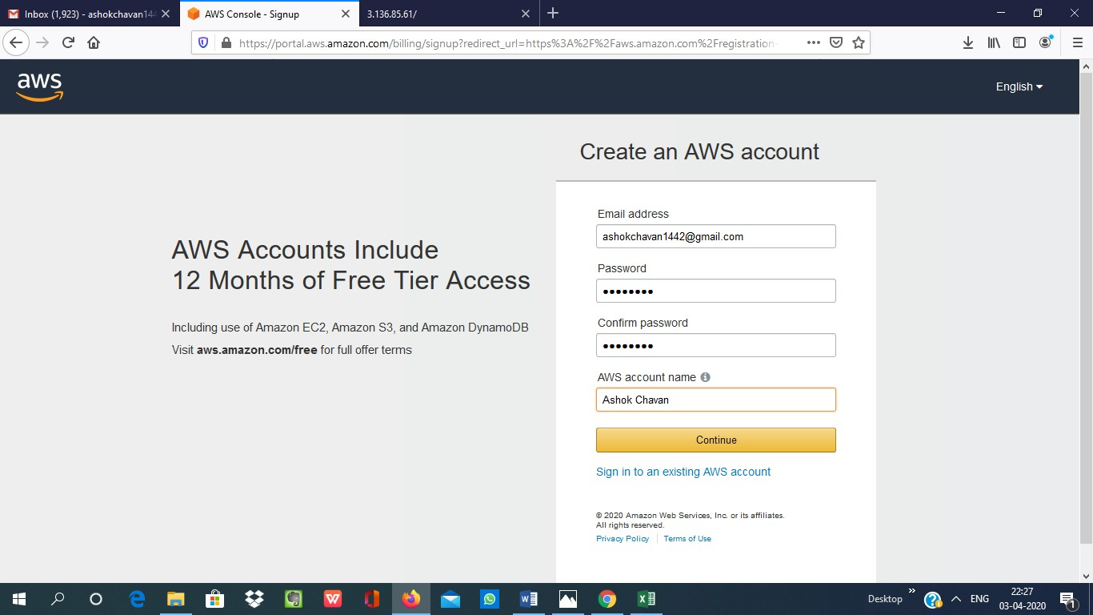

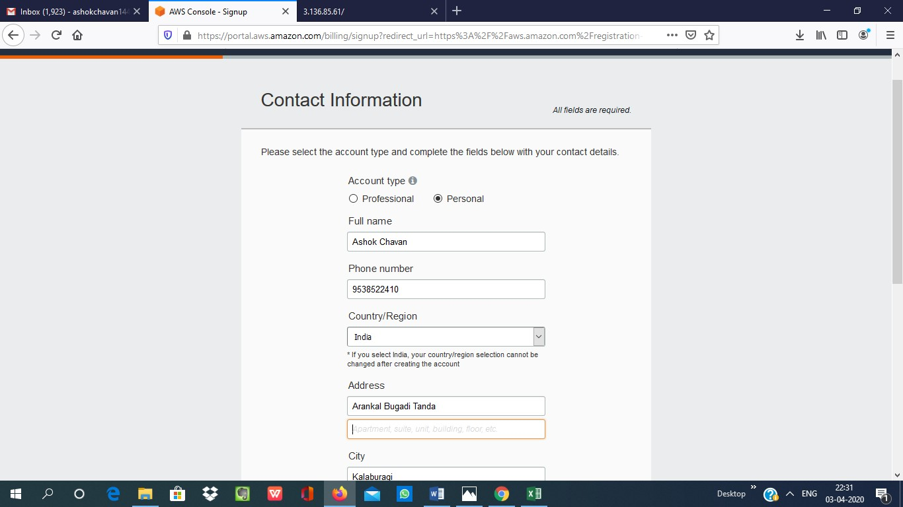

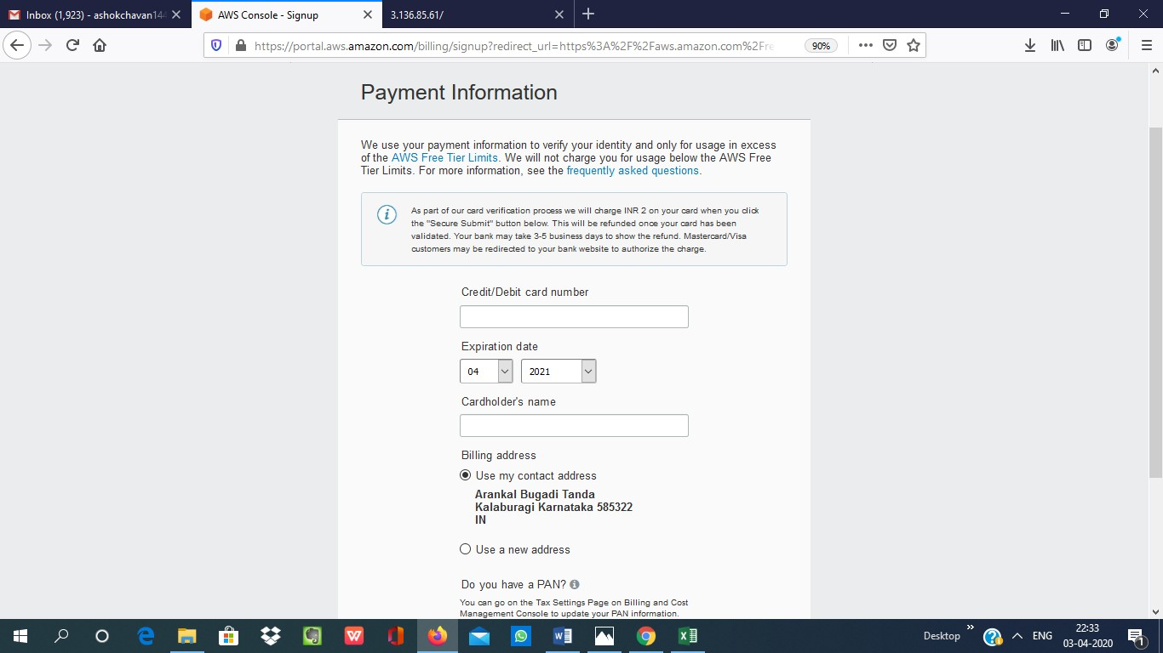

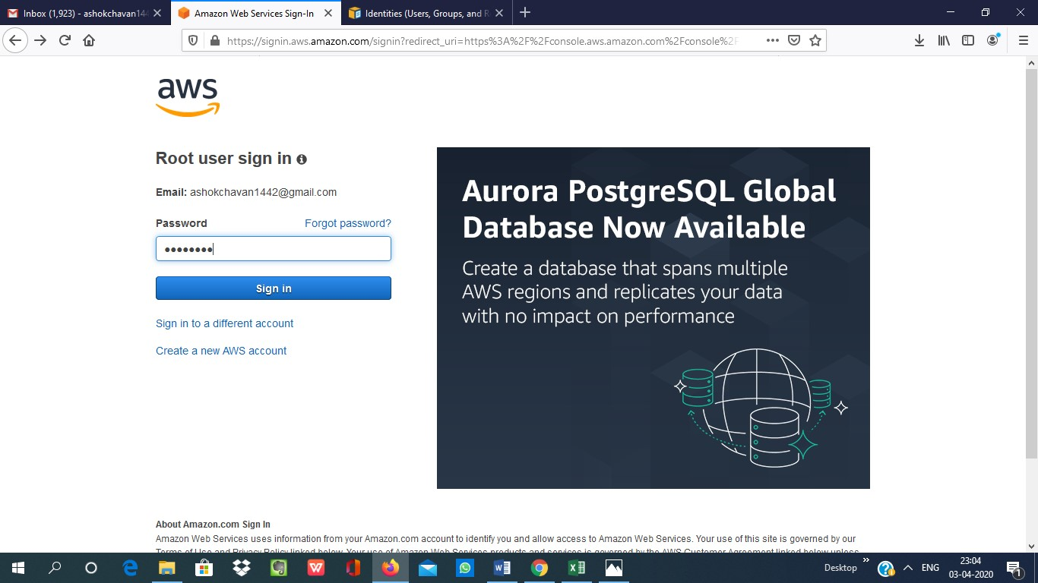

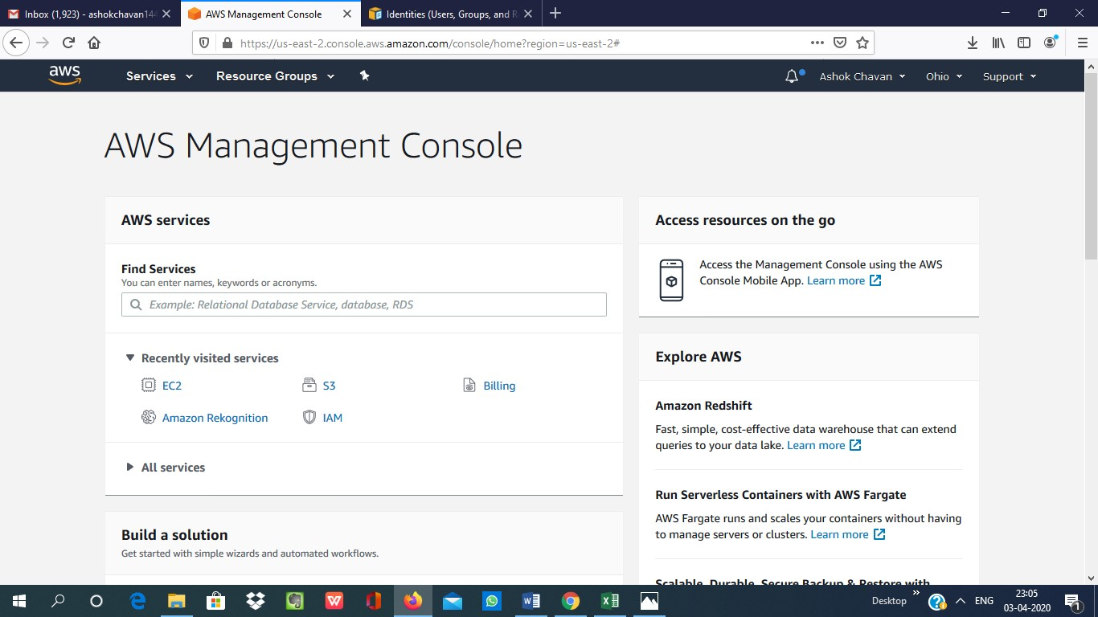

**EC2 Dashboard**

**1.Choosing an AMI**

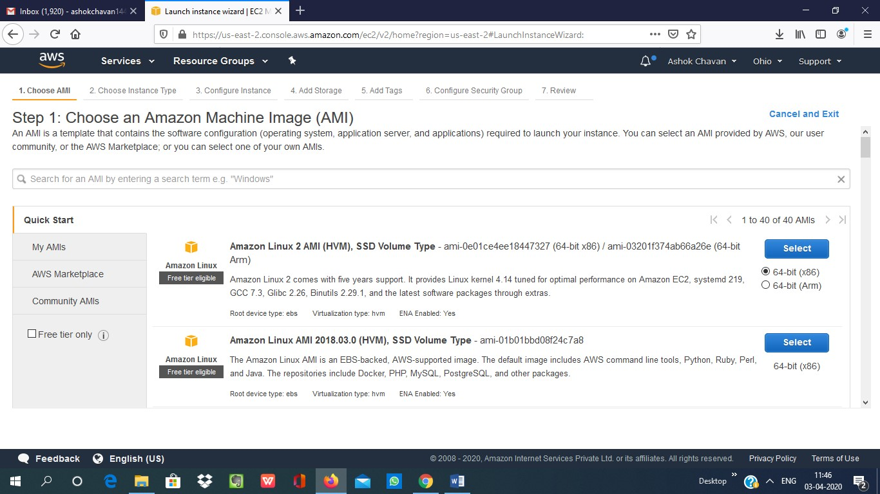

**2.Choosing an Instance Type**

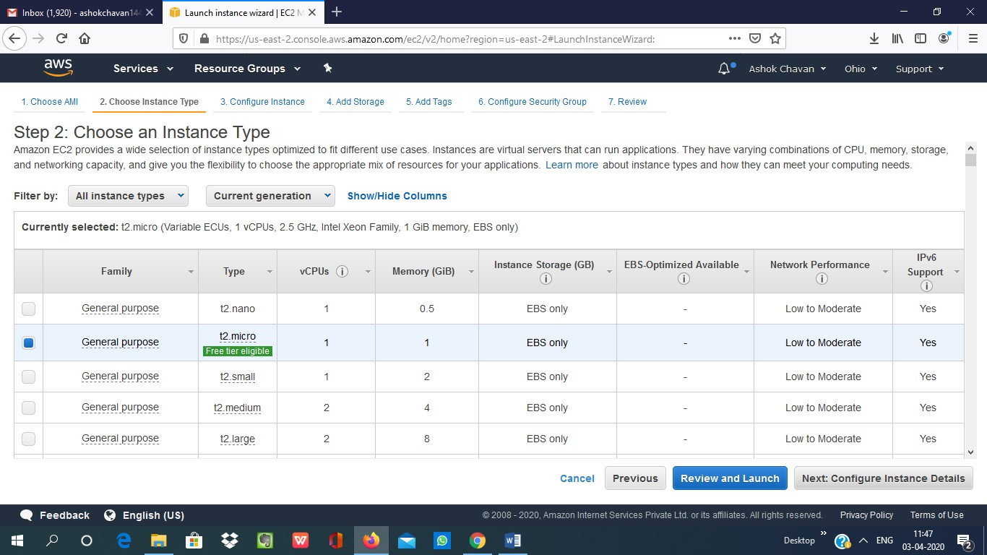

**3.Adding Storage**

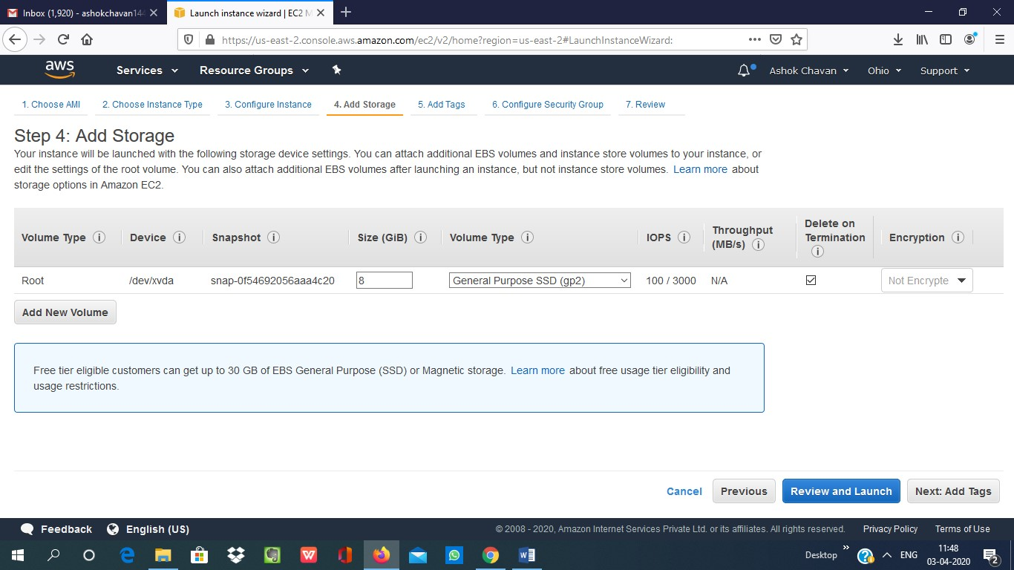

**4. Configuring Security Group**

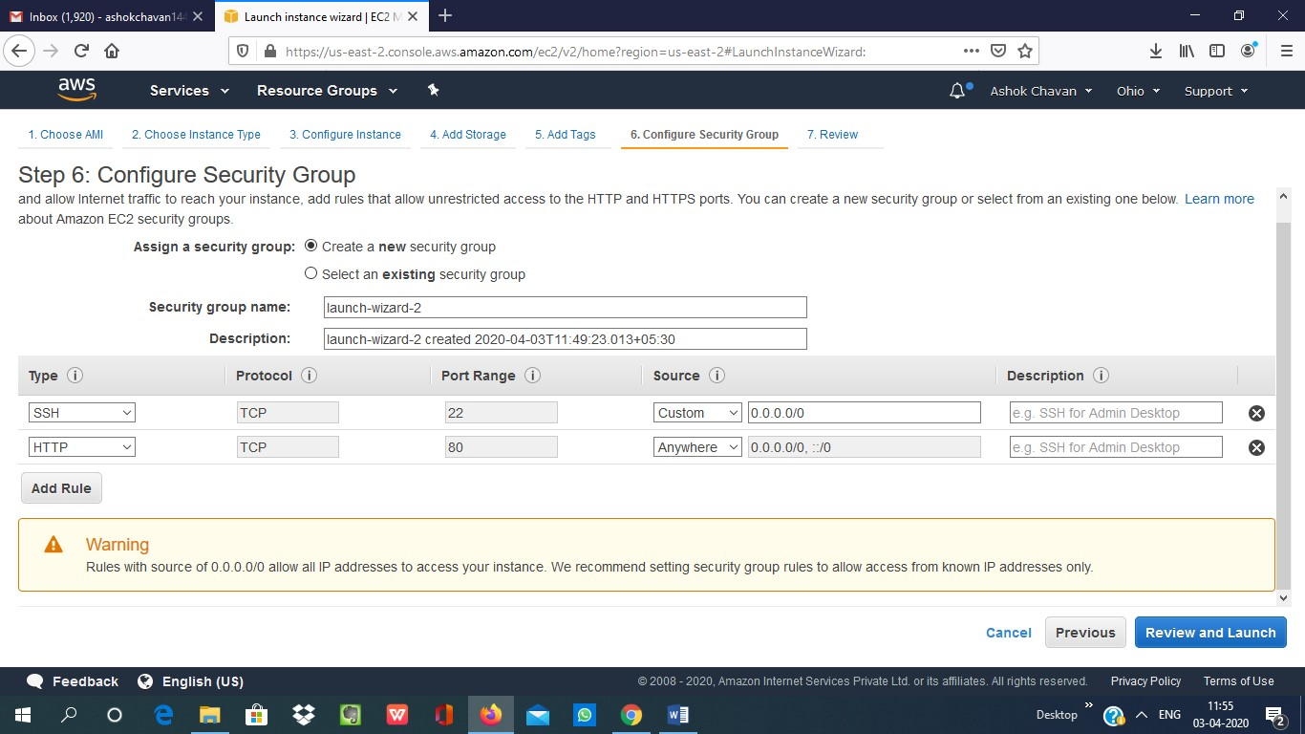

**5.Key Paid Download**

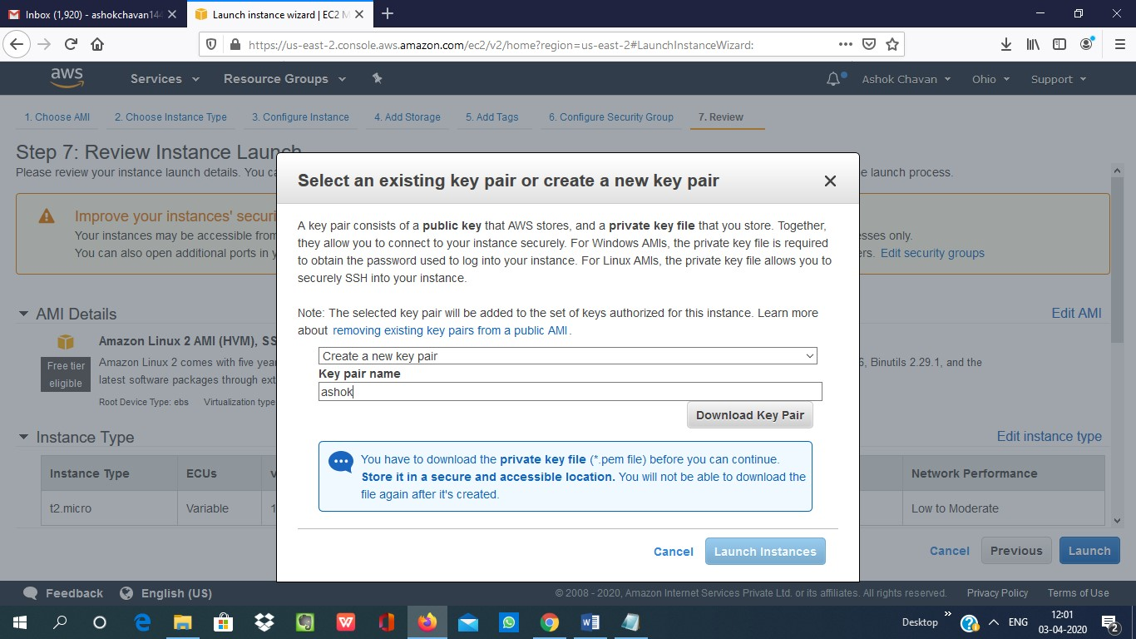

**6.PuTTYgen conversion from pem to ppk**

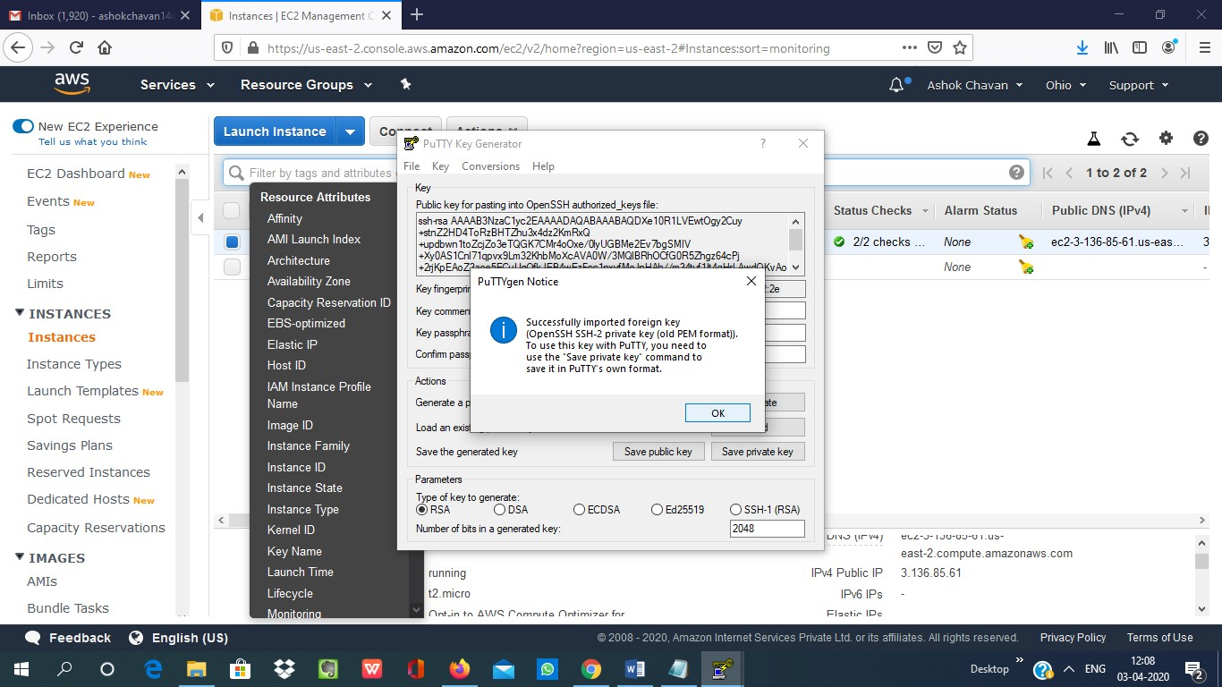

**7. Logged in EC2 black screen**

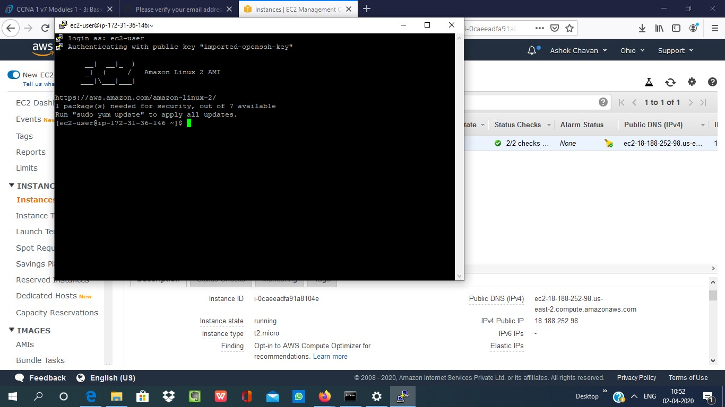

**3. S3 Dashboard**

**1. Creating a bucket**

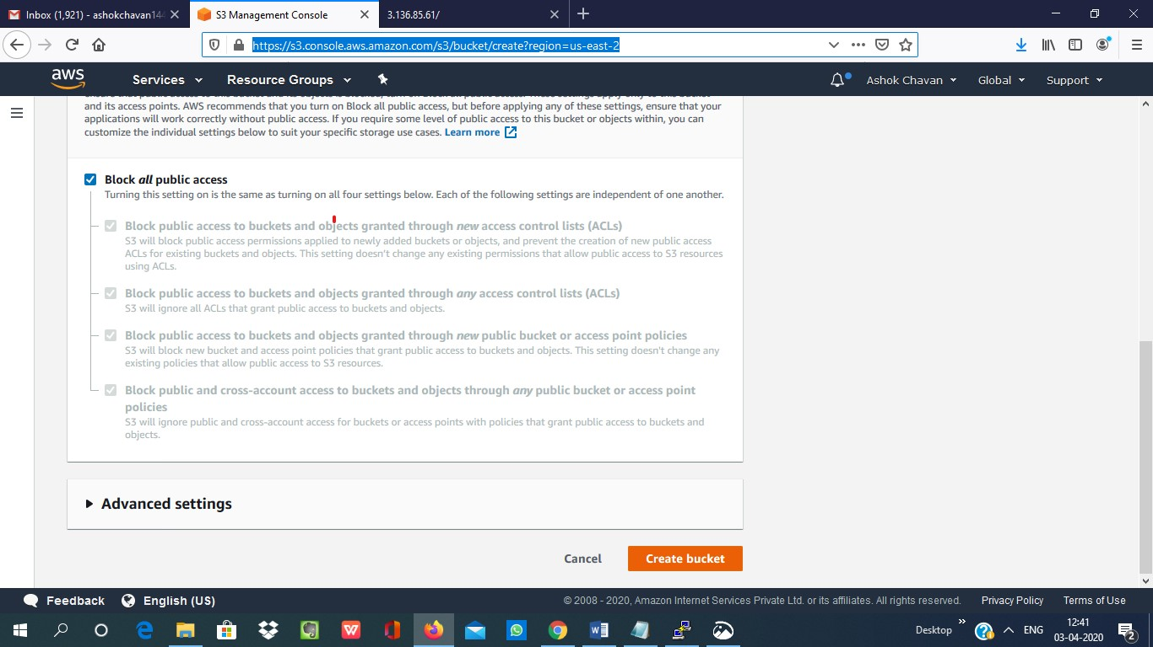

**2. Uploading an Object**

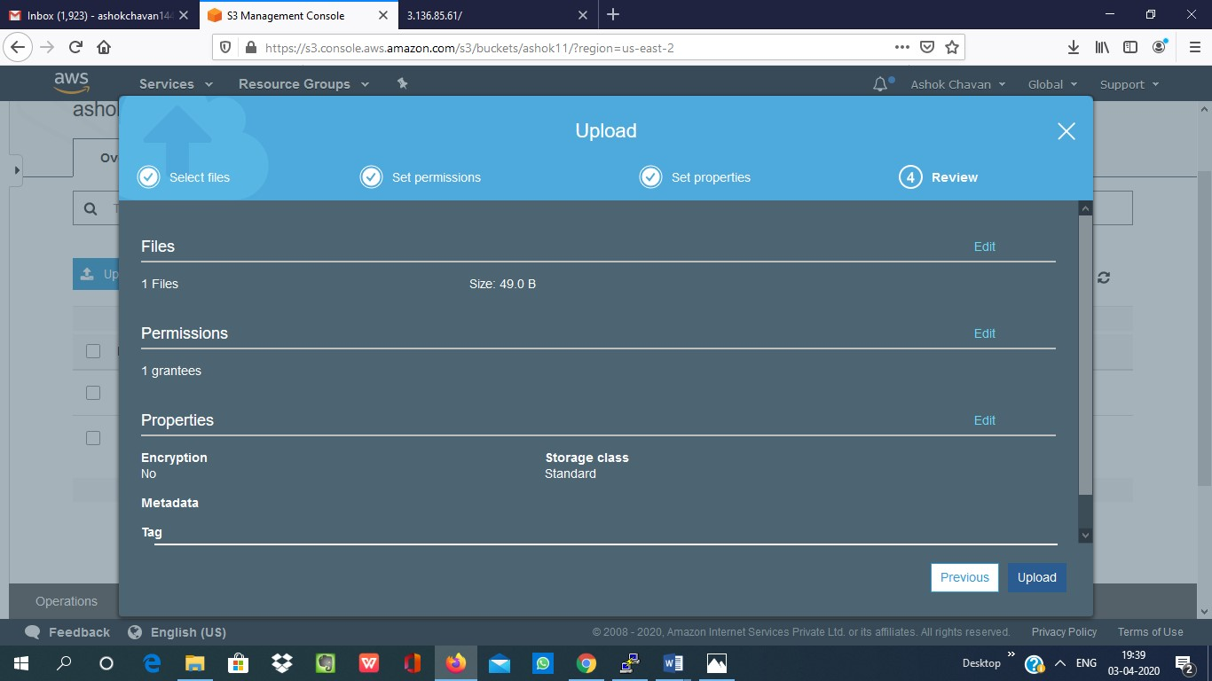

**3. Enabling Static Website**

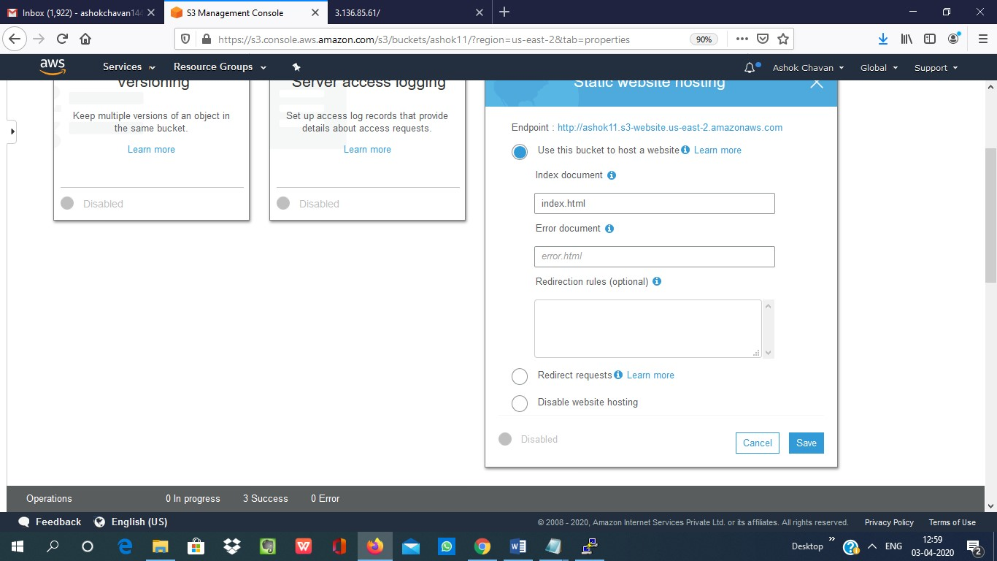

**4.Making the Object Public**

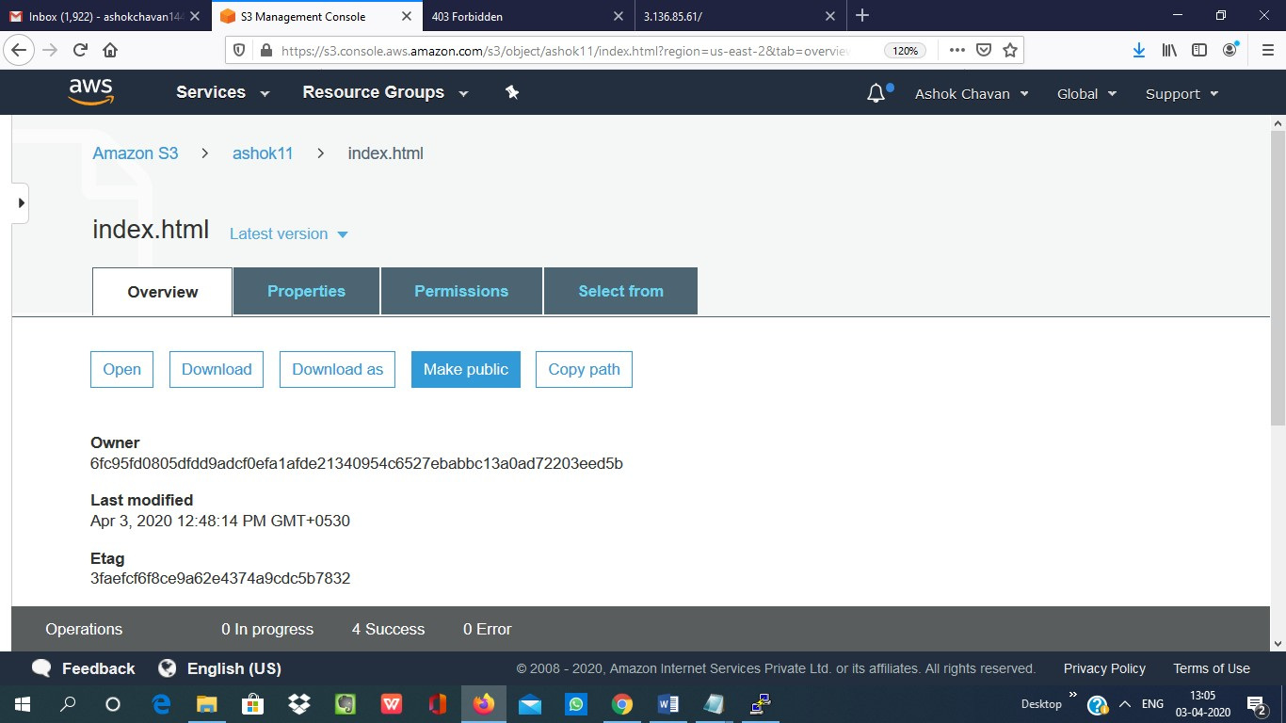

**5 .Checking the S3 link on the browser**

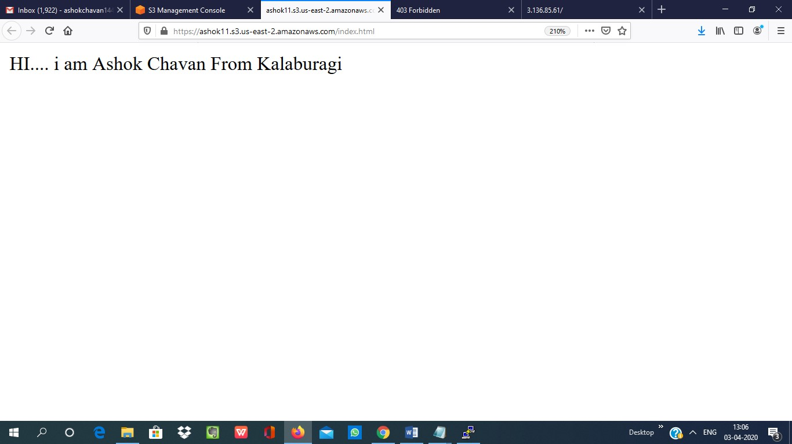

**Amazon Rekognition**

1. [**Facial analysis**](https://us-east-2.console.aws.amazon.com/rekognition/home?region=us-east-2#/face-detection)

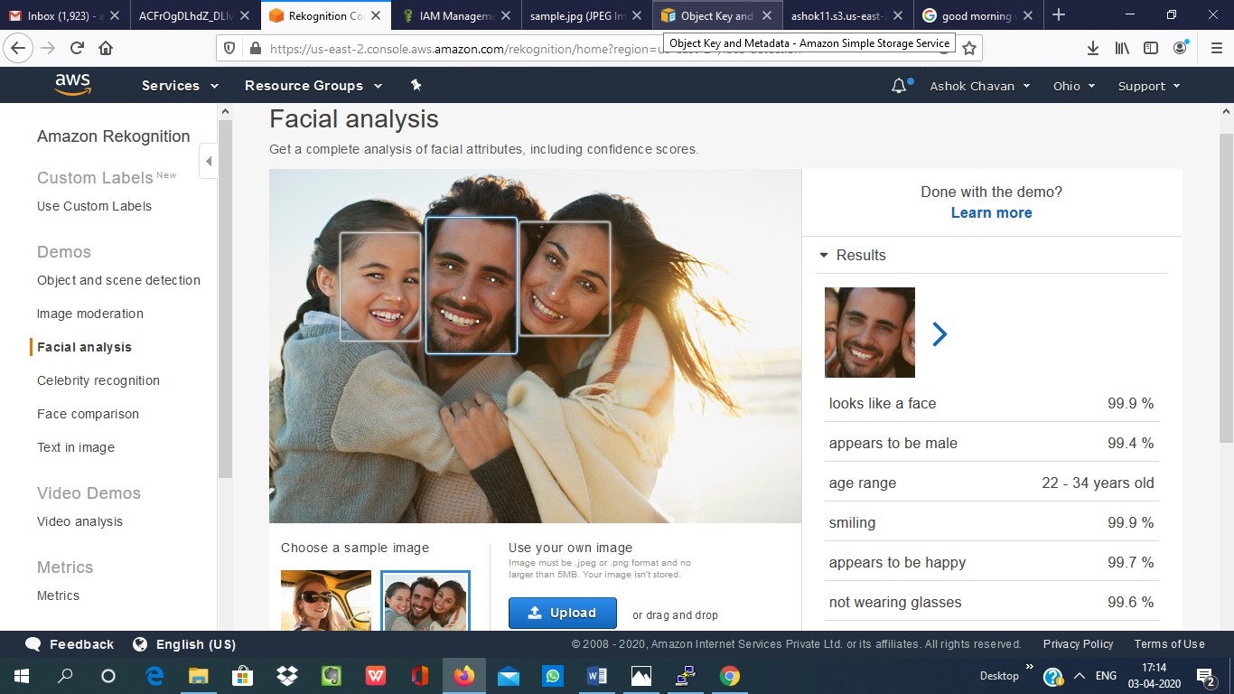

**2.[Face comparison](https://us-east-2.console.aws.amazon.com/rekognition/home?region=us-east-2" \l "/face-comparison)**

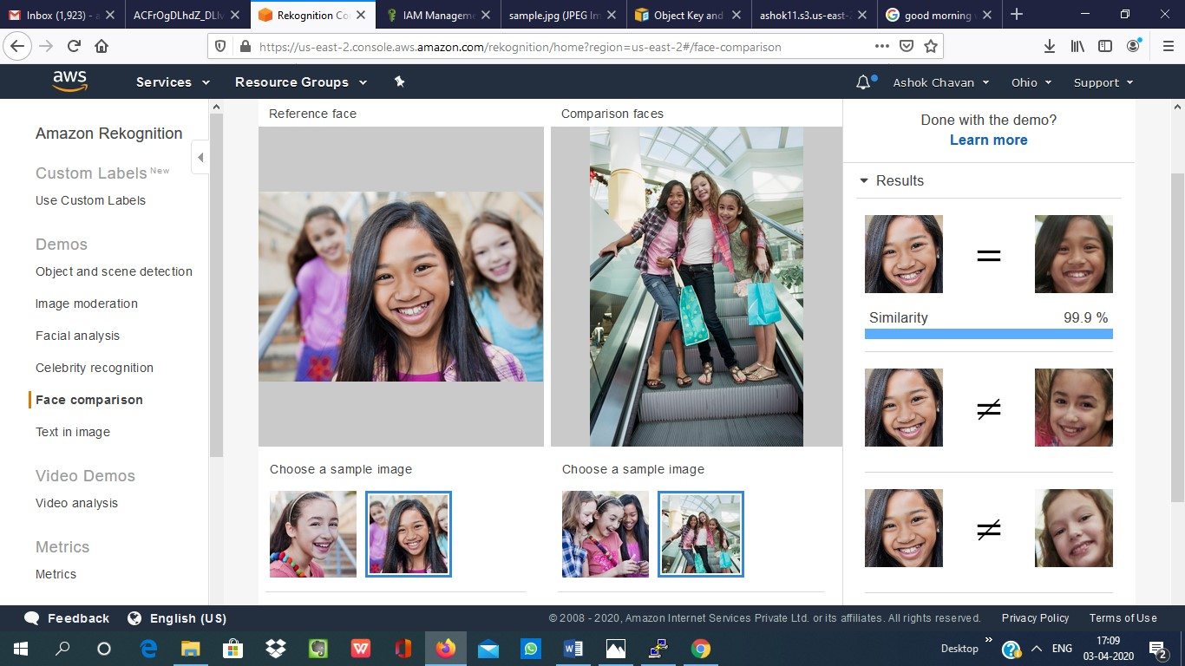

1. [**Celebrity recognition**](https://us-east-2.console.aws.amazon.com/rekognition/home?region=us-east-2#/celebrity-detection)

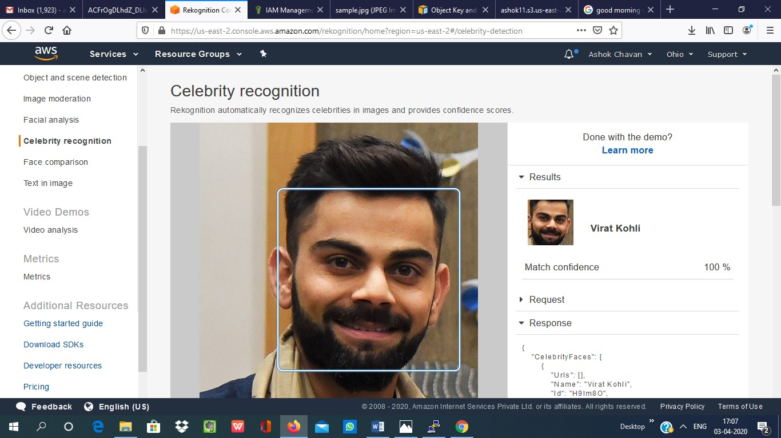

1. **[Text in image](https://us-east-2.console.aws.amazon.com/rekognition/home?region=us-east-2" \l "/text-detection)**

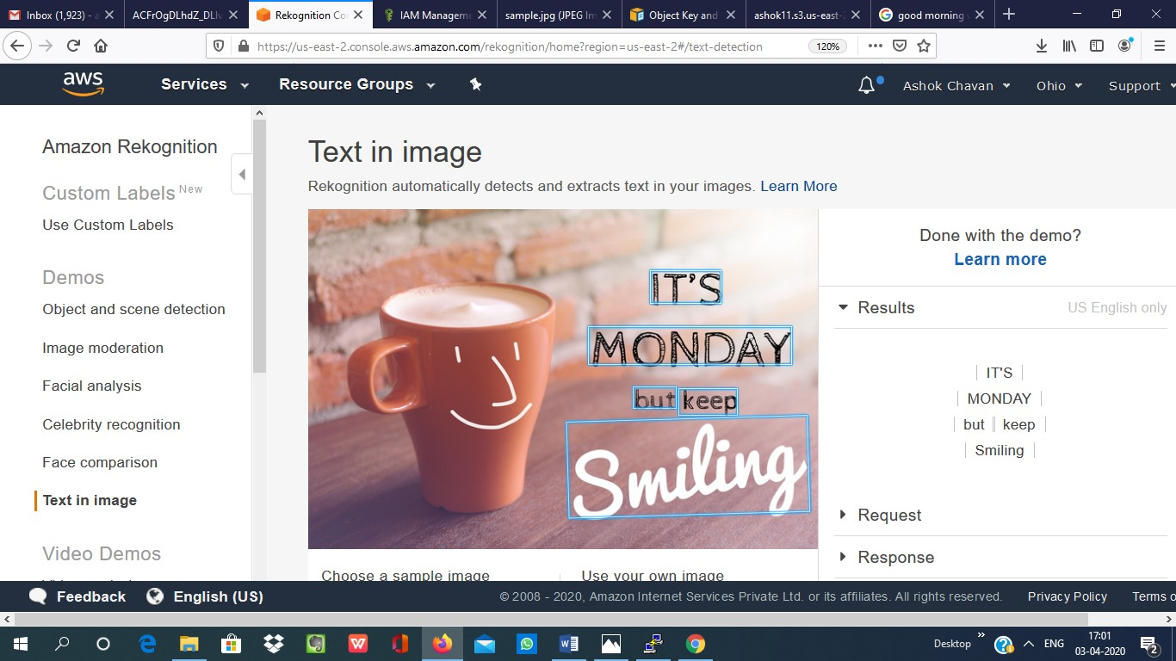

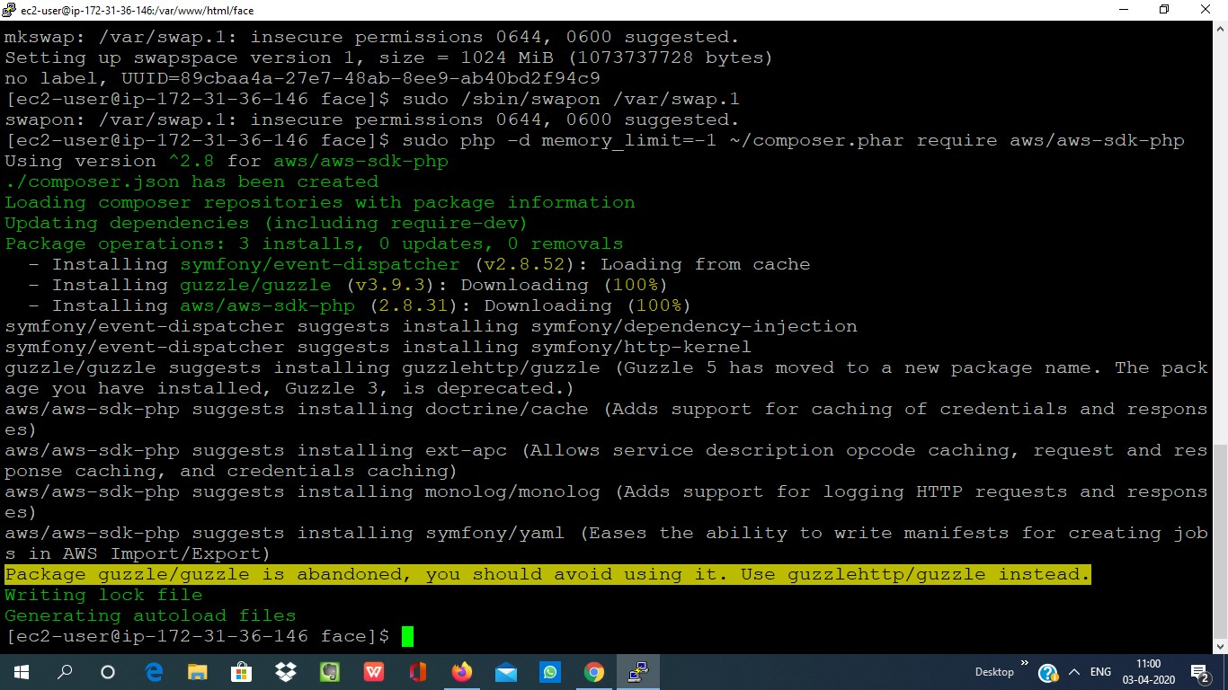EC2 AND S3

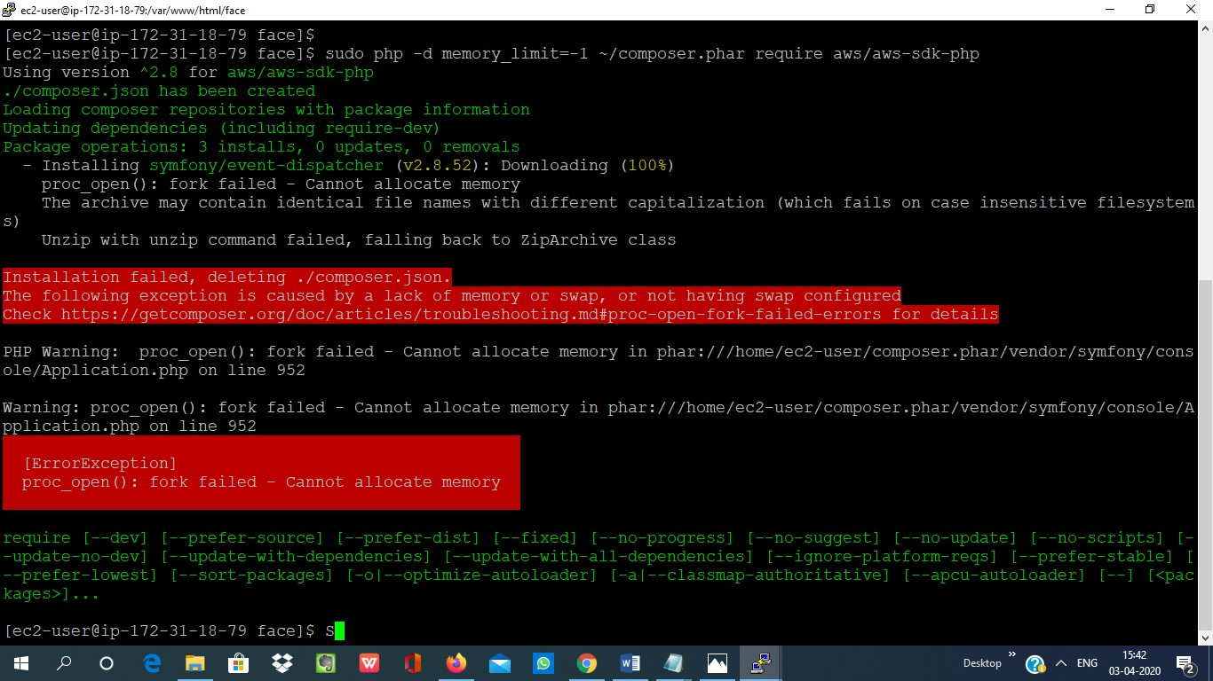**1. Installing aws-sdk**

**2. Installing php**

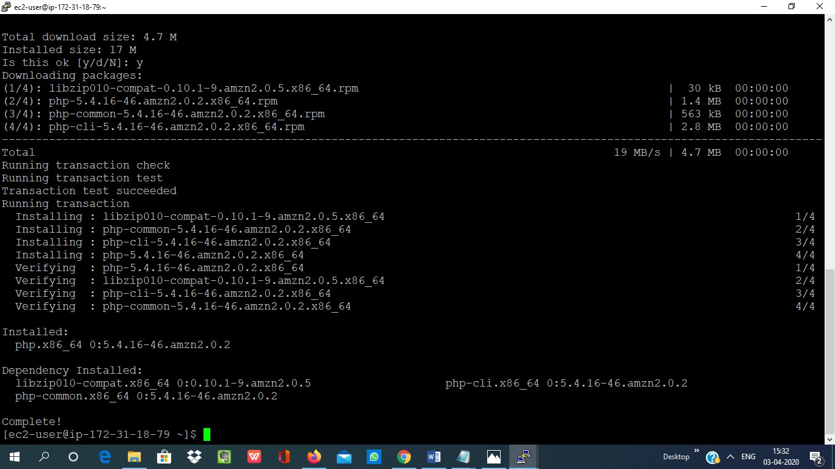

**3. Index.php file code**

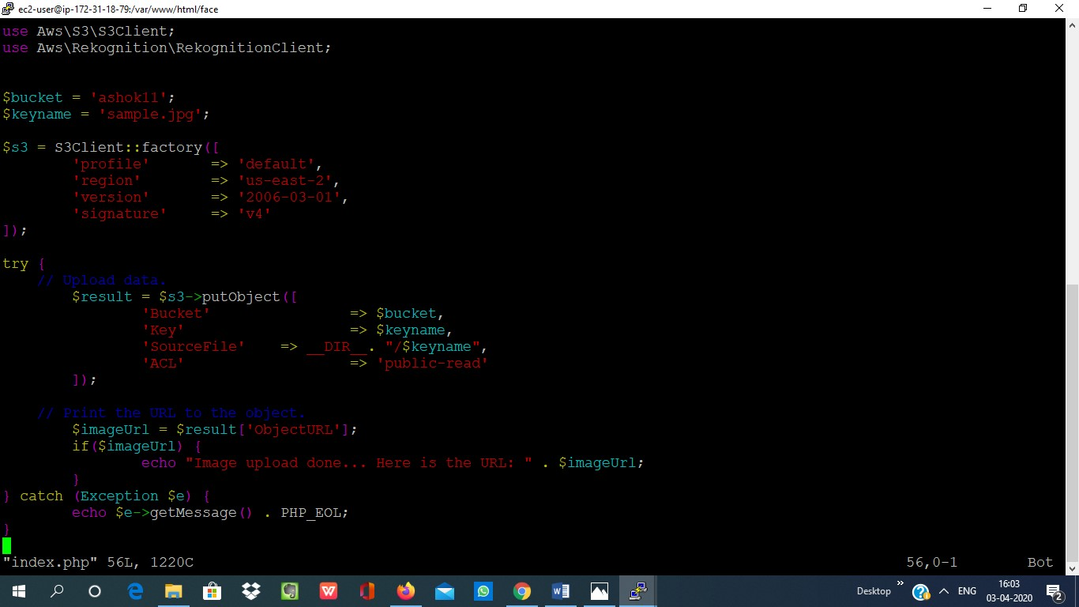

**4. UPOLOAD**

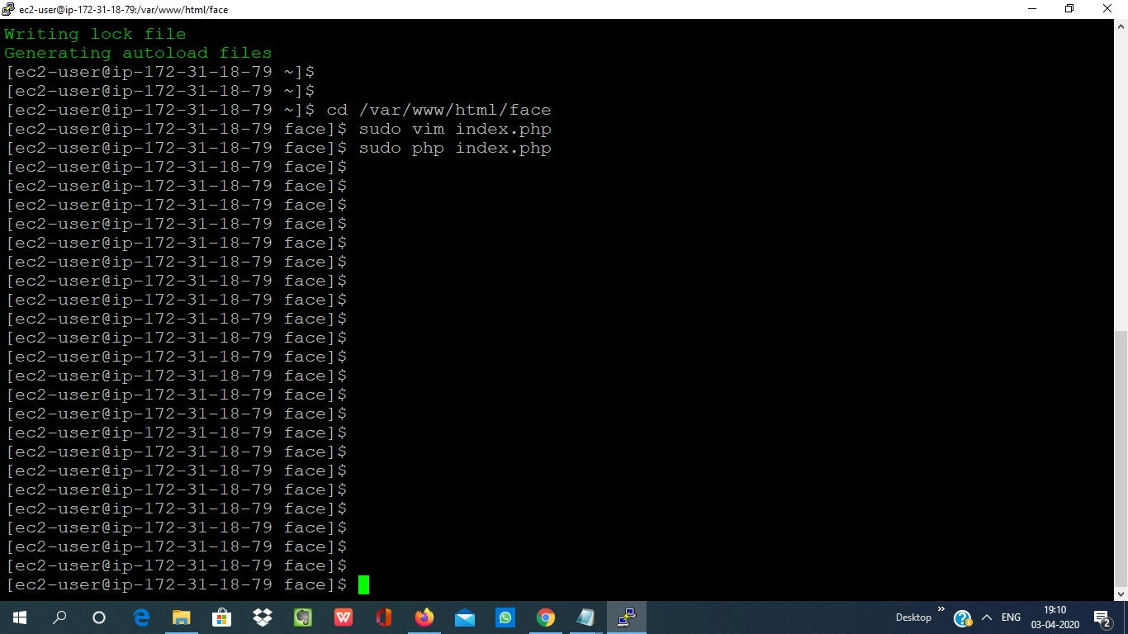

**EC2 AND REKOGNITION**

